Project Report: Text-Based Adventure Game in Python

Cover Page
Project Title: Text-Based Adventure Game
Name: Divyanshu Singh
Registration no.:25MIM10191

Introduction
This project is a simple text-based adventure game implemented in Python. The player navigates through different rooms in a mansion, collects items, and solves puzzles to eventually escape the mansion. The game is designed to demonstrate basic concepts of programming such as dictionaries, functions, loops, and condition handling.

Problem Statement
The problem tackled in this project is to create an interactive, engaging game that allows the player to explore a virtual mansion by moving between rooms, collecting items, and solving puzzles using those items. The challenge is to design a clear and functional text interface that allows the player to perform these actions smoothly.

Functional Requirements
- Allow player movement between rooms (north, south, east, west) based on available exits.
- Display room descriptions, items present, and available exits.
- Enable the player to pick up items in rooms.
- Enable the player to use items to solve puzzles (unlock chest, open main door).
- Track player’s inventory.
- Provide commands to interact with the game: go, get, use, inventory, quit.
- End the game successfully when the player solves the main puzzle and escapes.

Non-Functional Requirements
- The game should run on any machine with Python installed.
- User input should be robust to invalid commands and provide feedback.
- The game should have a simple, clear text interface without graphical elements.
- The code should be modular and easy to understand or extend.

Implementation Details
The game is structured around a dictionary representing rooms, each containing descriptions, items, exits, and puzzles. The player’s current location and inventory are tracked with variables. The main game loop continuously prompts the player for input, processes commands, updates the state, and provides feedback.
The puzzles involve using specific items (key, torch, knife) in certain rooms to progress:
- Unlocking a locked chest in the bedroom with the key.
- Using the torch and knife together to pry open the main exit door and win the game.

Code Snippet (Partial)
r = {
‘hall’: {
‘description’: “You are in hall.”,
‘items’: [‘torch’],
‘exits’: {‘north’: ‘bedroom’, ‘east’: ‘kitchen’, ‘west’: ‘study’, ‘south’: ‘exit’},
‘puzzle’: None
},
# other rooms …
}

Challenges Faced
- Handling user input errors gracefully while maintaining game flow.
- Managing state between rooms, items, and puzzles.
- Designing puzzles that require item usage logically and clearly.
- Ensuring the game ends cleanly upon solving the final puzzle.

Learning and Key Takeaways
- Reinforced understanding of Python dictionaries and functions.
- Practical experience with game loop design and input handling.
- Learned how to structure a simple interactive text-based application.
- Gained experience implementing game logic with conditions and inventory management.

Future Enhancements
- Add more rooms, items, and complex puzzles.
- Implement a save/load feature to resume gameplay.
- Add player stats or health for a more immersive experience.
- Enhance user interface with colors or better formatting.
- Support multi-word item names and commands.

Output Screenshots
Screenshot 1: Starting the game and picking up torch and key in study.
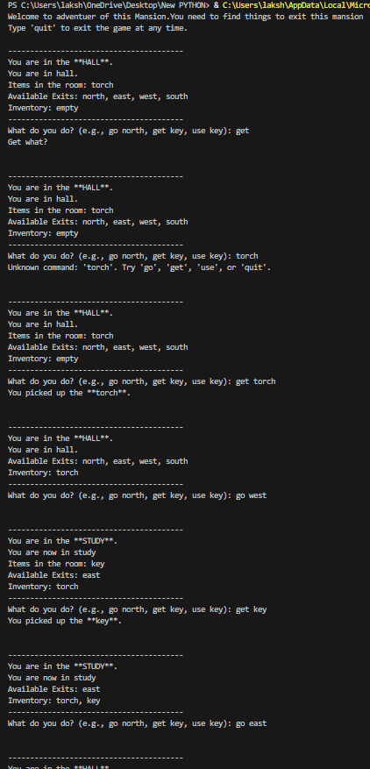
Screenshot 2: Game showing error for incorrect command, picking up torch and key again.
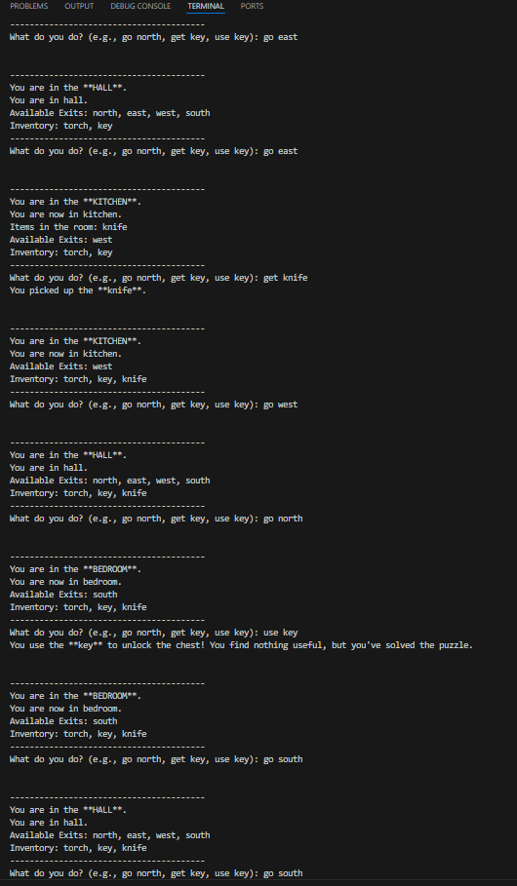
Screenshot 3: Picking up knife, unlocking chest with key, moving rooms.
